Perceptron Features

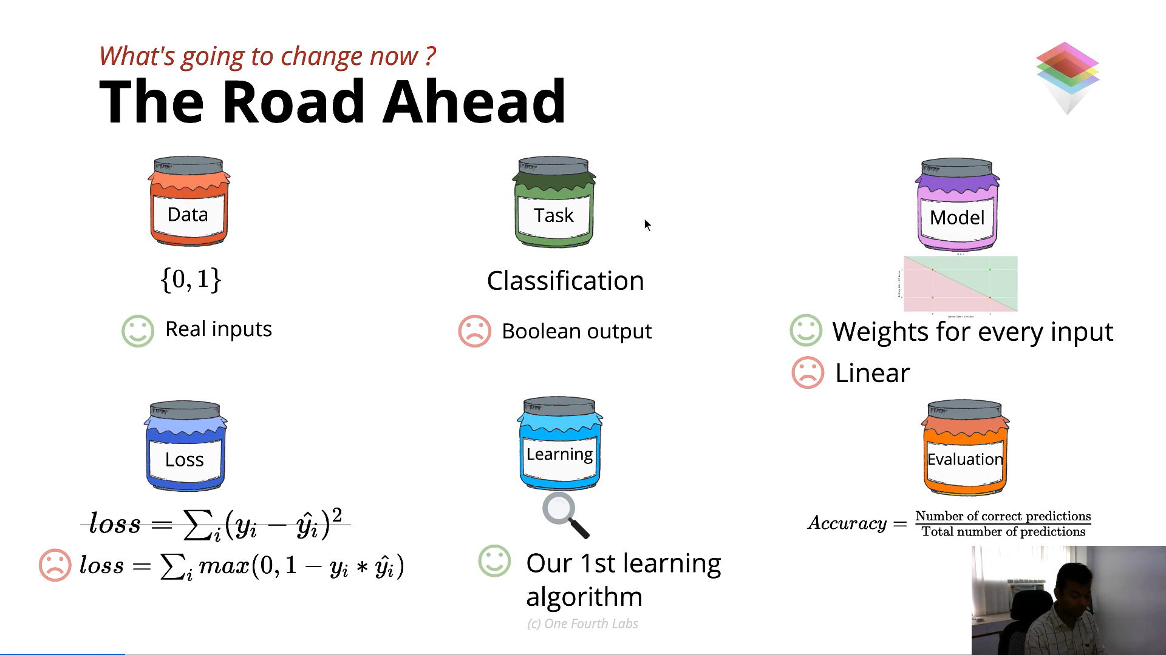

Data Standardization

* Reduces all real nos to values bw 0 to 1

